Harriers Globe Trotters | Topic: Investigating Rivers | Main Subject: Geography - Rivers | Year 5/6 Summer Term
What should I already know?
- he Water Cycle
- How we use rivers
- Major rivers of the World
- Rivers in our local area
Key Vocabulary
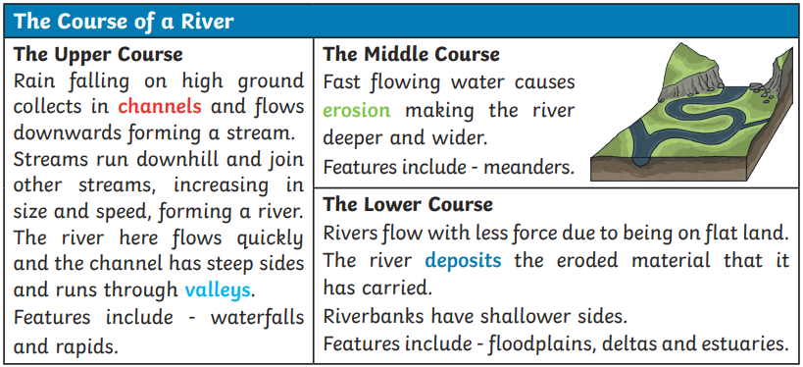
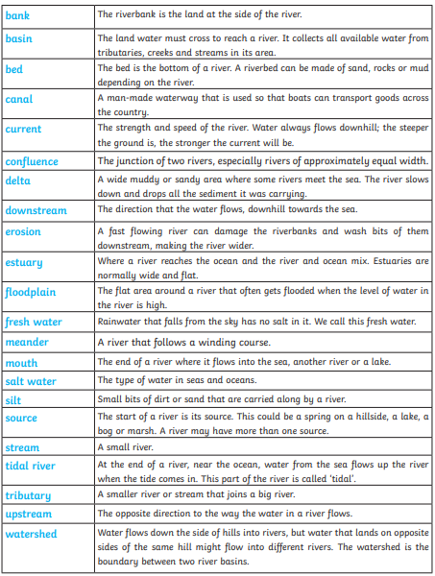

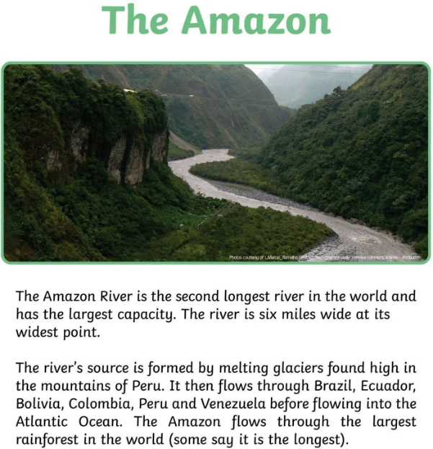
What will I know by the end of this topic?
- I will know the features of a river
- I will know the human and physical causes of flooding
- I will know about the features, plants and animals, people and the economy of the Amazon River
