Anglo-Saxon Invasion
- Match the events with the date that it happened.
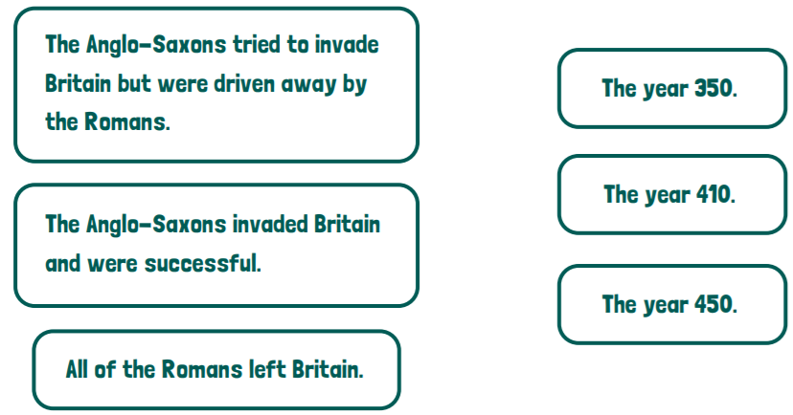
- Why do you think that the place names shown on this map originated in the Anglo-Saxon era?
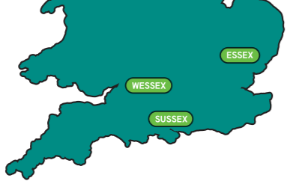

- Give 3 reasons why the Anglo-Saxons invaded Britain.

- When did the Anglo-Saxons leave Britain?

