5th January 2021
Re-write the sentences correcting the circled spelling.
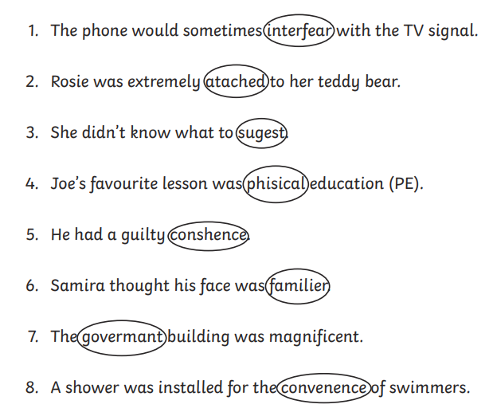

Re-write the sentence with the correct spelling. Use your Year 5/6 Spelling List to find the correct spellings.

