Time Worksheet
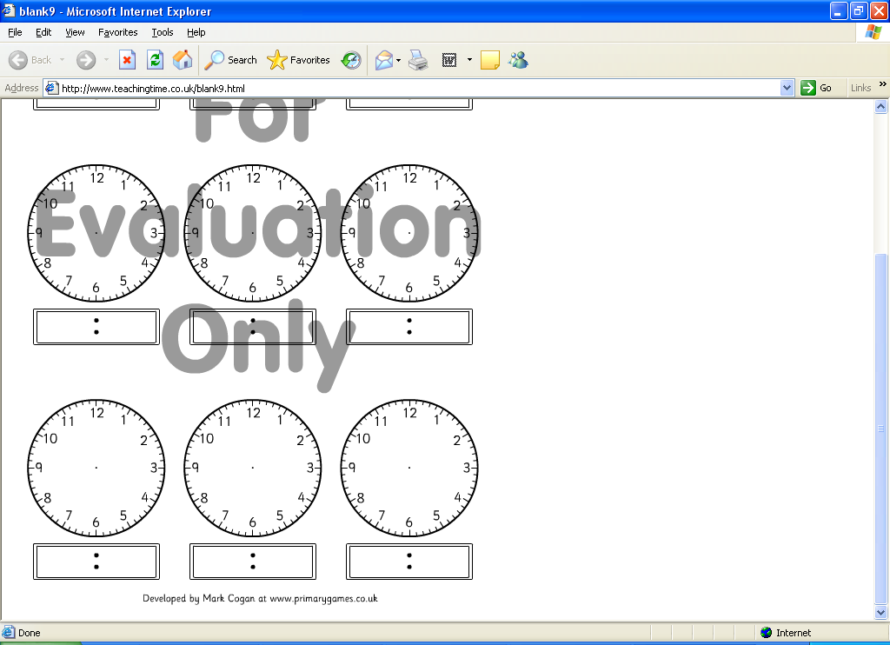
Read the time on either the digital or analogue clock and fill in the missing time.

